Variation Summary

Path : Reports >> Variation Summary.

Steps to reach Variation Summary:
Step 1 : Reports in Steps to reach Variation Summary : Open the Reports module from the main Billing Application(POS).
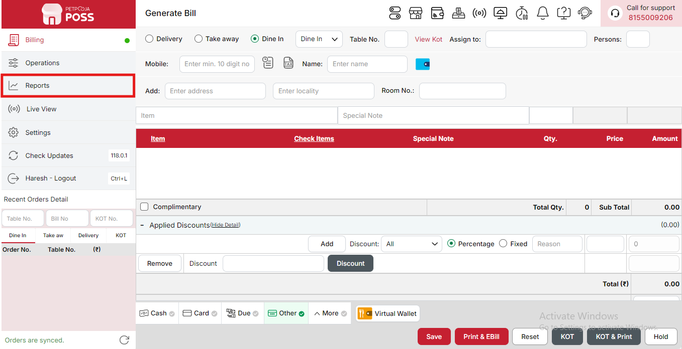
{Image Name: Reports Option,
Description: The red box highlights the “Reports” option in the sidebar menu. This section allows users to view and analyze various business reports, such as sales, billing, and order summaries, helping in effective tracking and decision-making.Here is an image of Step 1 Report in Steps to Reach Variation Summary.}
Step 2 : Variation Summary in Steps to reach Variation Summary : Select Variation Summary to view detailed sales data for each item variation, including quantity sold and total revenue generated.
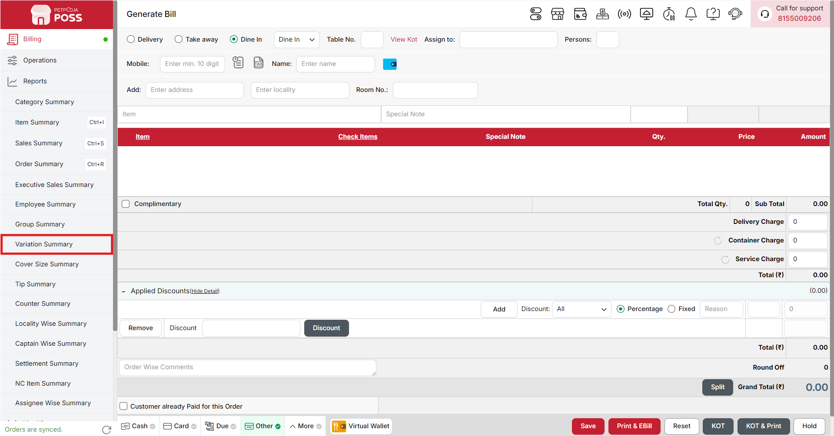
{Image Name: Variation Summary,
Description: The red box highlights the Variation Summary option under the Reports section. This feature provides detailed insights into product variations, helping users track sales and performance of different item variants such as size, flavor, or customization options.Here is an image of Step 2 Variation Summary in Steps to Reach Variation Summary.}

Key features of Variation Summary :
(Variation Summary) Note: If you are not able to see or use the Variation Report option in your billing application, it means that you do not have the required permission. To enable this, you need to go to the Owner Dashboard and open the User Management section. Inside User Management, you will find a permission called Variation Summary Show Button — you must checkmark this option to give access.If you are not able to view old day reports, then you also need to enable the Days Restriction permission. Inside the same User Management section, select No Restriction so that you can view reports for any date.After allowing these permissions, perform a manual sync so the system updates the rights properly. Once the sync is done, log out from the billing application and then log in again. After this process, the Variation Report option will become visible, and you will be able to view all reports without any problem.

- (Variation Summary) Variation Report - [Date]: Displays a detailed summary of product variations sold on the selected date. It helps track performance and sales of items based on their size, type, or variation, such as Small or Large.
- (Variation Summary) Variation: Represents the classification of items based on size or type. For example, Small and Large variations are listed separately to show their individual sales performance.
- (Variation Summary) Item: Lists the specific items under each variation. This helps identify which items within each size or type contribute to total sales.
- (Variation Summary) Code: Displays the unique code assigned to each item. It helps in easy identification and tracking of products in the system.
- (Variation Summary) Qty.: Shows the total quantity sold for each item under a particular variation. It indicates how many units of each variation were sold.
- (Variation Summary) Total (₹): Displays the total sales value for each item or variation. It helps analyze revenue generated from each product type or size.
- (Variation Summary) Sub Total: Summarizes the total quantity and total sales for each variation group, such as Small or Large. It provides a clear view of variation-wise performance.
- (Variation Summary) Total: Represents the overall total of all variations combined. It gives the complete sales summary, including total quantity and total value for all product variations on the selected date.
Search Button (Variation Summary) : The Search button is used to find the report for a specific date or time. It helps you quickly see sales details for the selected period. After choosing the date or time, you can click on Search to view the report.
- From (Variation Summary) : The From option is used to select the starting date for the variation report. It means the report will begin from this date.
- To (Variation Summary) : The To option is used to select the ending date for the variation report. It means the report will show data up to this date.
- Variation (Variation Summary) : The Variation option provides a dropdown list of all the variations you have created. You can select a specific variation from the list to view its detailed report for the selected date range.
- Time Wise Option (Variation Summary) : The Time Wise Option is used when you want to see the report for a specific time period within a day. After turning it ON, you can choose both date and time — for example, from 10:00 AM to 5:00 PM — to see sales during that time. If you keep this option OFF (Without Time Wise Option), then the report will show the whole day’s data for the selected date range without filtering by time.
Configure Column (Variation Summary) : Used to show or hide different columns in the report by checking or unchecking the boxes. If you want to see that option in the report, you have to check it, and if you want to hide it, you have to uncheck it.
- (Configure Column) Orders: Shows how many orders were placed for each product. You can check this to see it in the report or uncheck it to hide it.
- (Configure Column) Items: Shows the total number of items sold for each product. You can check this to show it in the report or uncheck it to hide it.
- (Configure Column) Net Amount (₹): Shows the total amount received from sales before tax and after discounts. You can check this to view it in the report or uncheck it to hide it.
- (Configure Column) Total Discount (₹): Shows the total discount given on each product. You can check this to show discount details or uncheck it to hide them.
- (Configure Column) Total Tax (₹): Shows the total tax amount added to the sales. You can check this to see tax details or uncheck it to remove it from the report.
- (Configure Column) Total Sales (₹): Shows the total amount earned after adding tax and applying discounts. You can check this to display it in the report or uncheck it to hide it.
- (Configure Column) Percentage (%): Shows how much each item contributes to the total sales in percentage. You can check this to view the percentage or uncheck it to hide it from the report.
(Variation Summary) Print Button: The Print Button is used to print the report. If you want to take a printout of the report, you just need to click on the Print button.
If you get an error saying “Please assign one printer for report print”, then follow these steps:
- Go to Operation → Bill/KOT Print → Multiple Printer Settings.
- Select and edit one printer that you want to use for printing the report.
- In that printer setting, there is an option called “Use this printer for report print”.
- Check this box and save the setting.
After doing this, you will be able to print the report successfully using the selected printer.
(Variation Summary) Print Configuration: This section is used to set how your report will look when you print it. You can change the format, size, and what details to show on the printed page.
- (Print Configuration) Format Preference: Used to select the layout or design of the printed report.
- (Print Configuration) Show Bill Header: If you check this option, the header (top part with company or shop name) will appear on the print.
- (Print Configuration) Show Bill Footer: If you check this option, the footer (bottom part with notes or messages) will appear on the printed report.
- (Print Configuration) NONE: Select this option if you don’t want to apply any specific print format or layout. The report will print in the default basic format without additional formatting or sections.
- (Print Configuration) Display To Date on Print: If you check this option, the “To Date” of the report will be shown on the printed page.
- (Print Configuration) Display Time on Print: If you check this option, the time will be displayed on the print along with the date.
- (Print Configuration) Display Summary Box on Print: If you check this option, a summary box will appear at the end of the report showing total amounts and other summary details.
- (Print Configuration) Display Print Date & Time on Print: If you check this option, the date and time when the report was printed will appear on the print.
- (Print Configuration) Main Width: Used to set the width of the report on the printed page. For example, 500 means the report will be printed with that width size.
- (Print Configuration) Font Size: Used to set the text size of the printed report. You can increase or decrease it as needed.
- (Print Configuration) Cancel: Click this button to close the print configuration window without saving any changes.
- (Print Configuration) Save:Click this button to save all the changes you made in the print configuration settings.
(Variation Summary) Export Excel: If you want to download or save the report in Excel format, you have to click on the Export Excel button. This will create an Excel file of the report that you can open and use in Microsoft Excel.

